**Install Java and Maven on Ubuntu 14.04 Server**

**Launch a t2.small VM with 20 GB SSD root disk**

##### **Step 1: Update your repo**

# apt-get update

**Step 2 :Install NTP & java packages**

# apt-get install ntp default-jdk

Install mysql

apt-get -y install mysql-server

Login to database

mysql -u root -p

Create a database for sonarqube and grant privlleges

mysql> CREATE DATABASE sonarqube;

mysql> GRANT ALL PRIVILEGES on sonarqube.* to sonarqube@'localhost' IDENTIFIED BY 'root1234';

mysql> quit

## Install Nginx as a Reverse Proxy

Add repository key. This will make sure apt can verify the Nginx package.

wget -c -O- http://nginx.org/keys/nginx_signing.key | sudo apt-key add -

Add Nginx.org repository

echo "deb http://nginx.org/packages/ubuntu/ trusty nginx" | sudo tee -a /etc/apt/sources.list.d/nginx.list > /dev/null

Update apt metadata and install nginx.

sudo apt-get update

sudo apt-get -y install nginx

Create two new directories named sites-available and sites-enabled with commands below:

mkdir /etc/nginx/sites-available

mkdir /etc/nginx/sites-enabled

Remove contents of /etc/nginx/conf.d

$ sudo rm -f /etc/nginx/conf.d/*

### http only configuration

vim /etc/nginx/sites-available/sonarqube.conf

server {

listen 80 default_server;

listen [::]:80 default_server;server_name sonarqube.exampleserver.xyz;

root /usr/share/nginx/sonarqube;proxy_set_header X-Forwarded-For $proxy_add_x_forwarded_for;

proxy_set_header Host $host;

proxy_set_header X-Forwarded-Proto $scheme;location / {

proxy_pass http://localhost:9000;

}

}

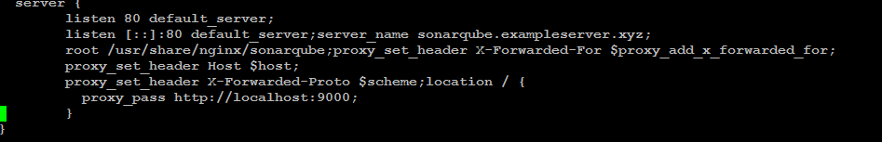

Enable configuration by creating symbolic link:

sudo ln -sf /etc/nginx/sites-available/sonarqube.conf /etc/nginx/sites-enabled/sonarqube.conf

Now restart Nginx

$ sudo service nginx restart